September 10th, 2006
Hi
Another week gone!
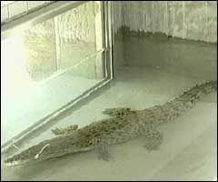
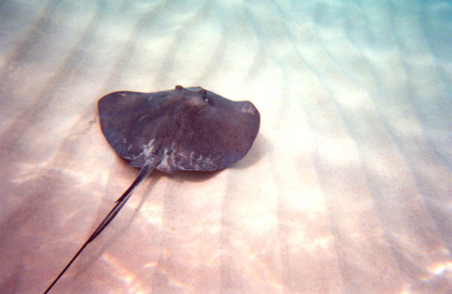

Remember the Yuen Long crocodile that evaded capture for a long time. News came through that the Australian chap, who came to HK to try to catch it, died in a freak marine accident. He was filming an underwater wildlife documentary and while swimming over a stingray, the fish speared him in the chest with its long sting, piercing his heart. Although he was able to pull out the sting, he died shortly afterwards. Apparently, he was more famous in the US than he was in Australia, because of the way they treat celebrities there. By the way, the crocodile, re-named ‘Pui-pui’ is living happily in its new home in the HK Wetland Park, which is situated about a mile from here.

Did a little bit less exercise this week. Only swam a total of 2.3 km for the three swims.
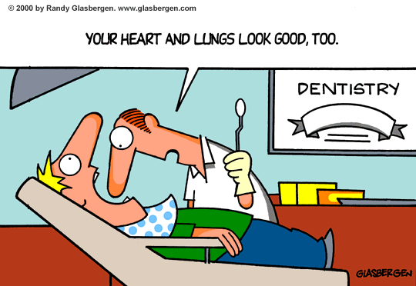

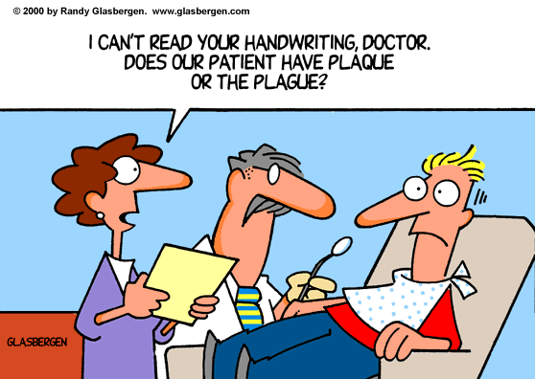
On Friday, I went to the dentist for a check up followed by cleaning. It is the first time I have been for a year and everything was OK. So, whatever I am doing to look after my teeth must be all right.

And now for the saga of the fly! Some time ago, a fly appeared. I think it might have come from fresh food I got from the supermarket. Well, for a while, it behaved itself but then it became a nuisance so I decided it was time to get rid of it. However, I think it got wind of the scheme as it made itself scarce. Trying to swat it with a towel turned out to be useless. Then I borrowed pesticide spray from the cleaning staff. But, do you think I could spray it? Not

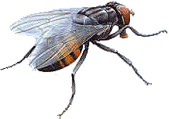
on your life; I could not find it anywhere! I even laid out some pesticide-laced food as 'bait' but that didn't work either. So, I just sprayed some of the pesticide on the carpet when I went out to the gym. I though I had finally killed the annoying thing using the pesticide as it didn’t appear. A day later, it turned up again! And it was tormenting me – buzzing around my head and crawling up my leg. Eventually I managed to swat it. It looked pretty dead so I put it in the toilet – but didn’t flush the toilet. Mistake! Later in
the day it appeared again - it must have been alive and managed to get out of the toilet bowl! Finally swatted it in evening and flushed it down the toilet this time! Whew! Actually, in the end I was beginning to feel a bit sorry for the fly – rather like the ‘Stockholm syndrome’ where a victim/prisoner begins to feel sympathetic towards his tormentor/captor.
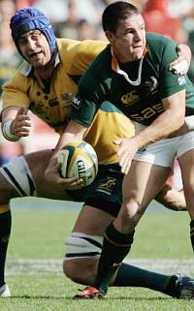
Yesterday saw the final match of the tri-nations series between Australia and South Africa in Johannesburg. The game was won by SA 24 – 16. So in the series, NZ had 5 wins. Australia and SA 3 wins each.
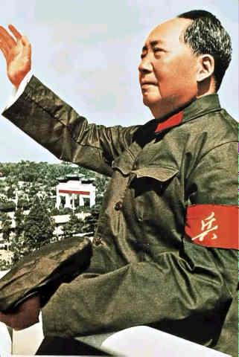
A couple of anniversaries. Yesterday was the 30th anniversary of the death of Chairman Mao Zedong. And tomorrow is the anniversary of the 9/11 attacks.

That seems to be it for now.

Cheers

